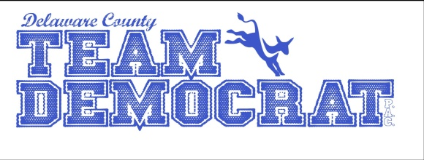

WE ARE NOT A POLITICAL PARTY, WE ARE A POLITICAL ACTION COMMITTEE (PAC). WE ARE DELAWARE COUNTY DEMOCRATS WHO SUPPORT POLITICAL CANDIDATES WHO AGREE WITH OUR CODE OF ETHICS.

TEAM DEMOCRAT’S CODE OF ETHICS

The Delaware County Team Democrat Political Action Committee supports political candidates and policies that promote political integrity, civil behavior, competency, and accountability in government, and transparency in all political actions. Specifically, the Team Democrat Political Action Committee and its endorsed candidates support:

- Political integrity that places the interests of the community above self and that of the political party.
  - Public office holders and appointees will recuse themselves from voting on any policy or issue in which they hold a conflict of interest.
  - Public office holders and appointees will represent all constituents without regard to political affiliation.
  - Employment and appointments will be made on the basis of merit as defined by education, training, and experience.
  - Endorsed candidates pledge not to hire immediate family members in any department or agency under their direct authority nor encourage other government officials to hire immediate family members.

- Behavior between political and community factions will be civil in tone and respectful.
  - Government officials will conduct public meetings using respectful language.
  - Political leaders and elected officials will not use intimidation or threats in their political interactions with other political leaders, office holders, or the public.

- All members of the Team Democrat Political Action Committee and the candidates it supports are accountable to the PAC and the public they serve.
  - All meetings of councils, commissions, and public office holders will be recorded and disseminated as required by their governing statutes.
  - All meetings of the PAC will be recorded and disseminated as required by the PAC bylaws.
  - All PAC members are welcome to participate at any and all PAC meetings.
  - All elected office holders are encouraged to be accountable and accessible to their constituents
  - responsive to their concerns and issues, and responsible in their representation.

- The Team Democrat Political Action Committee will only endorse candidates and office holders who subscribe to this code of ethics.

WHAT WE ARE ABOUT

- We have donated thousands of dollars to local and state candidates who have agreed to abide by our Code of Ethics;

- Team Democrat has supported statewide candidates for state superintendent of public instruction, secretary of state, and state auditor. Locally, we have supported State Representative Sue Errington, former Sheriff Mike Scroggins, County Coroner Scott Hahn, County Commissioner and County Council member, Larry Bledsoe, City Council member Linda Gregory and several circuit court judges.

- For candidates that we support, we walk, telephone, Facebook, deliver campaign signs, contribute money, raise funds, and assist our candidates in various other ways;

- We never ask our candidates for money.

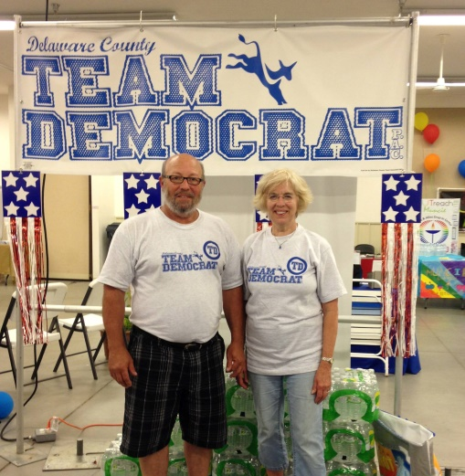

If you support the TEAM DEMOCRAT PAC Code of Ethics and would like to join, please complete the following and send it along with a yearly (January 1-December 31) membership fee of $10.00 to
TEAM DEMOCRAT PAC
P.O. BOX 445
MUNCIE, IN 47308

Name __________________________________
Address ________________________________
________________________________
E-mail _________________________________
Cell Phone ______________________________
Home Phone ____________________________
I am interested in participating in the following way(s). (Please check all that apply).
_____ Contacting voters
_____ Delivering yard signs
_____ Displaying a yard sign
_____ Campaign Walking
_____ Hosting a fund raiser
_____ Assisting with a fund raiser _____ Volunteering at Team Democrat headquarters
_____ Volunteering at the county fair
_____ Participating in political parade
Other ___________________________

TEAM DEMOCRAT PAC MISSION: The Delaware County Team Democrat Political Action Committee supports political candidates and policies that promote political integrity, civil behavior, competency and accountability in government, and transparency in all
political actions

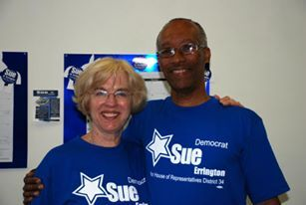
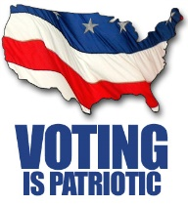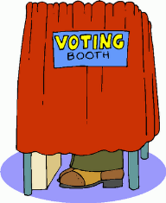
Register to vote at www.Indianavoters.com

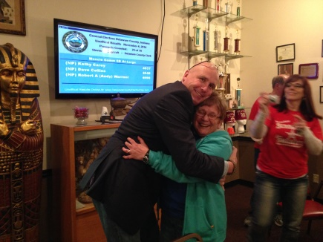
teamdemopac@gmail.com

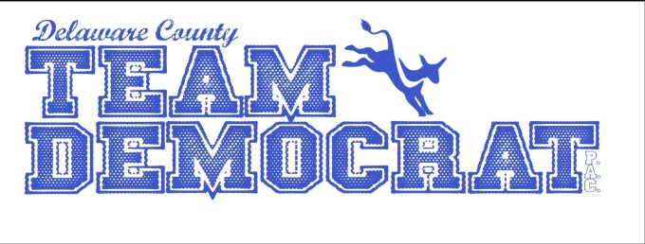

A DELAWARE COUNTY DEMOCRAT POLITICAL ACTION COMMITTEE SUPPORTING A
CODE OF ETHICS
FOR MUNCIE & DELAWARE COUNTY ELECTED OFFICIALS

